**BA 5200 - Information Systems Management**

**Finance - Credit Group**

**Call to Order:** 7:30pm

**Attendance:** [Joseph Williams](mailto:jokwilli@mtu.edu), [Irene Trierweiler](mailto:iltrierw@mtu.edu), Emily Wood, Reyn White, Trent Magers, Lukas Kendall

**Join Meeting Online:** [**https://michigantech.zoom.us/j/89331600895**](https://michigantech.zoom.us/j/89331600895)

**Minutes from Last Meeting:**

* None

**Agenda**

* Discuss flows regions of credit teams interaction with the other teams.
* Draft a working document of User and App interaction.
* Start collaboration on LucidChart, getting the team accustomed with tools.
* Reviewed Project deadlines and

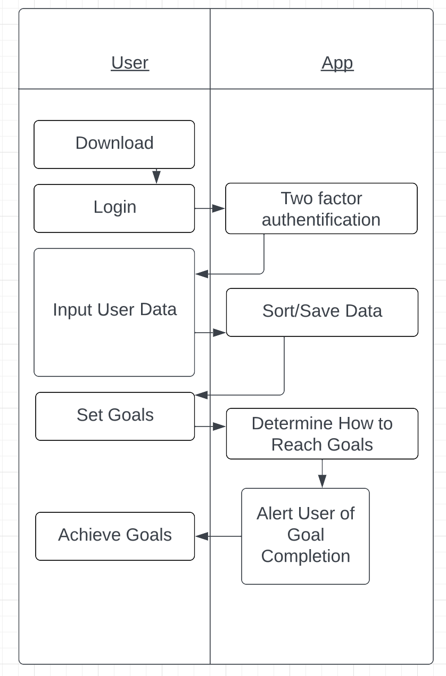

*Goals/Actions for the next meeting:*

* Review Lucid Chart tools for our next team meeting.
* Stand by for future instructions on Discord from [Sneha Karki](mailto:snehak@mtu.edu).

*Next Meeting Date:* Sunday, September 24th, 2023 at 7:00pm